***Web Technologies***

***Development Project1***

**Name: Rahul Challa**

**CWID: 20079716**

**MSIS517L**

**Professor: Michael Gildein**

**🡪 Design of my Resume Webpage:**

homepage.html is the main page which contains Home, Skill Set, Work Experience tabs and a button to the left to download the Resume.

The below pictures are the HTML validation results of homepage.html, skillset.html, portfolio.html

**🡪 Code Validations:**

* **Homepage.html**

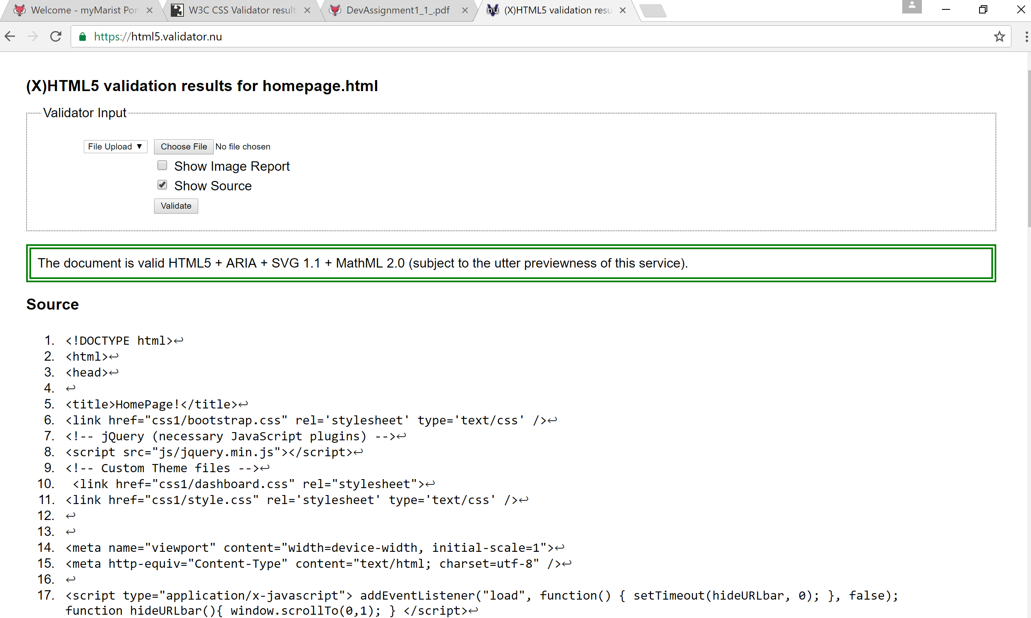

Figure: homepage.html validation result

* **Skillset.html**

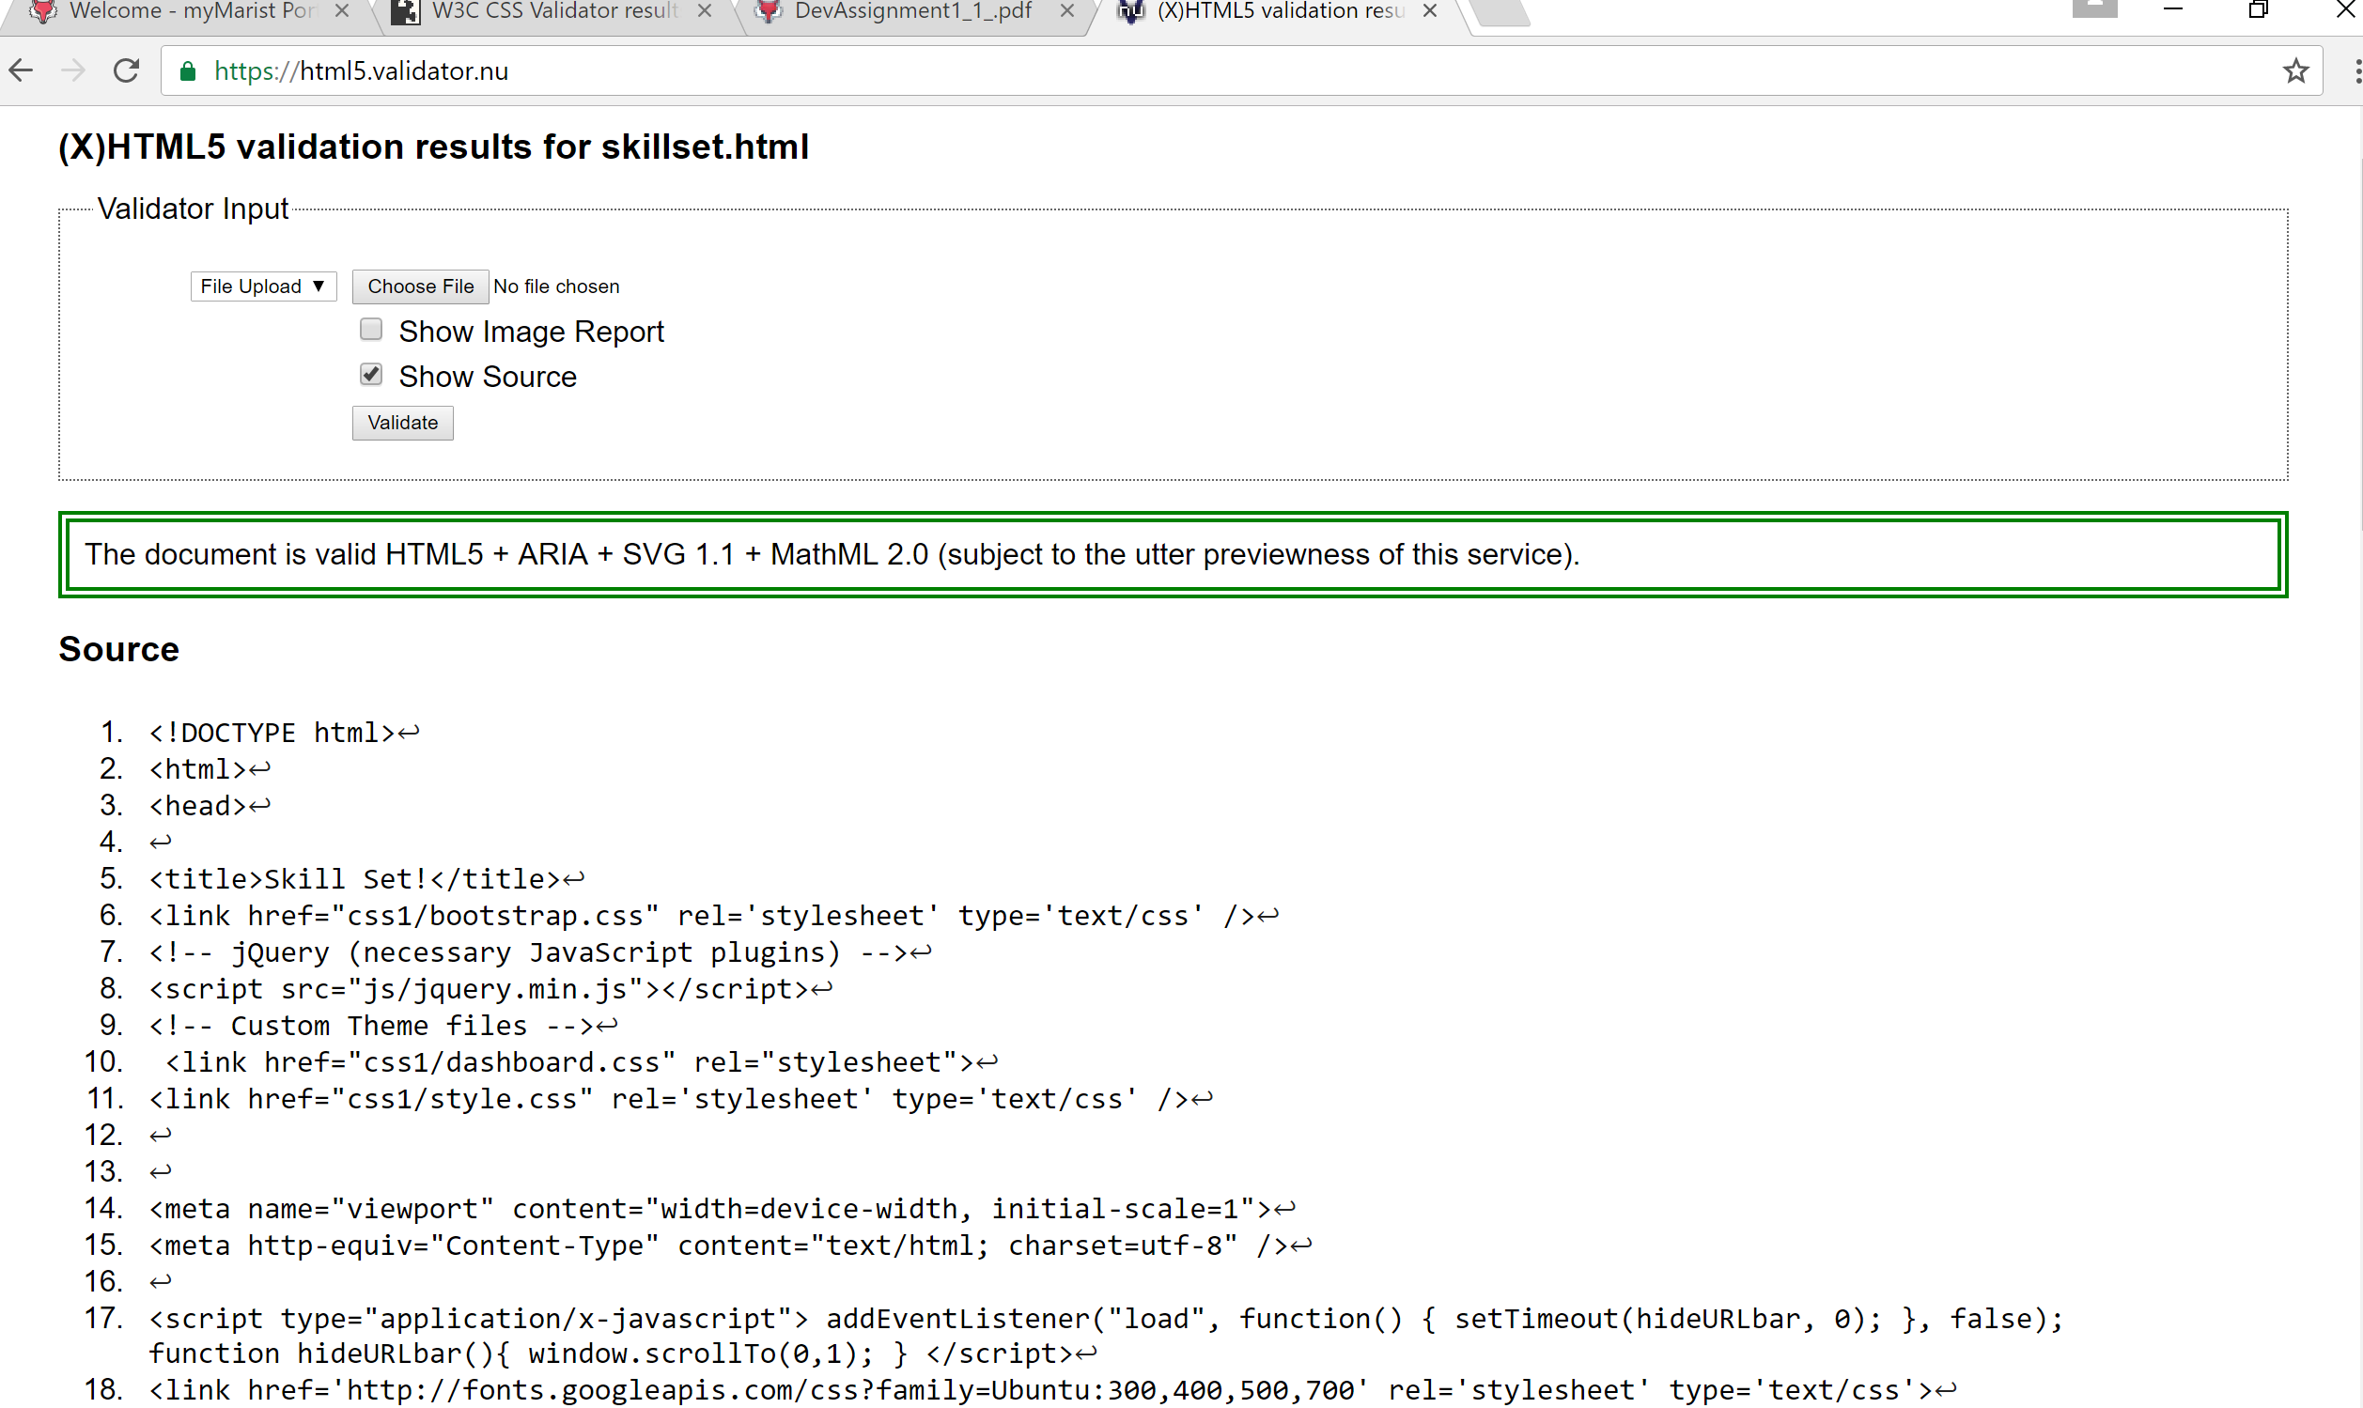

Figure: skillset.html validation result

* **Portfolio.html (Work Experience)**

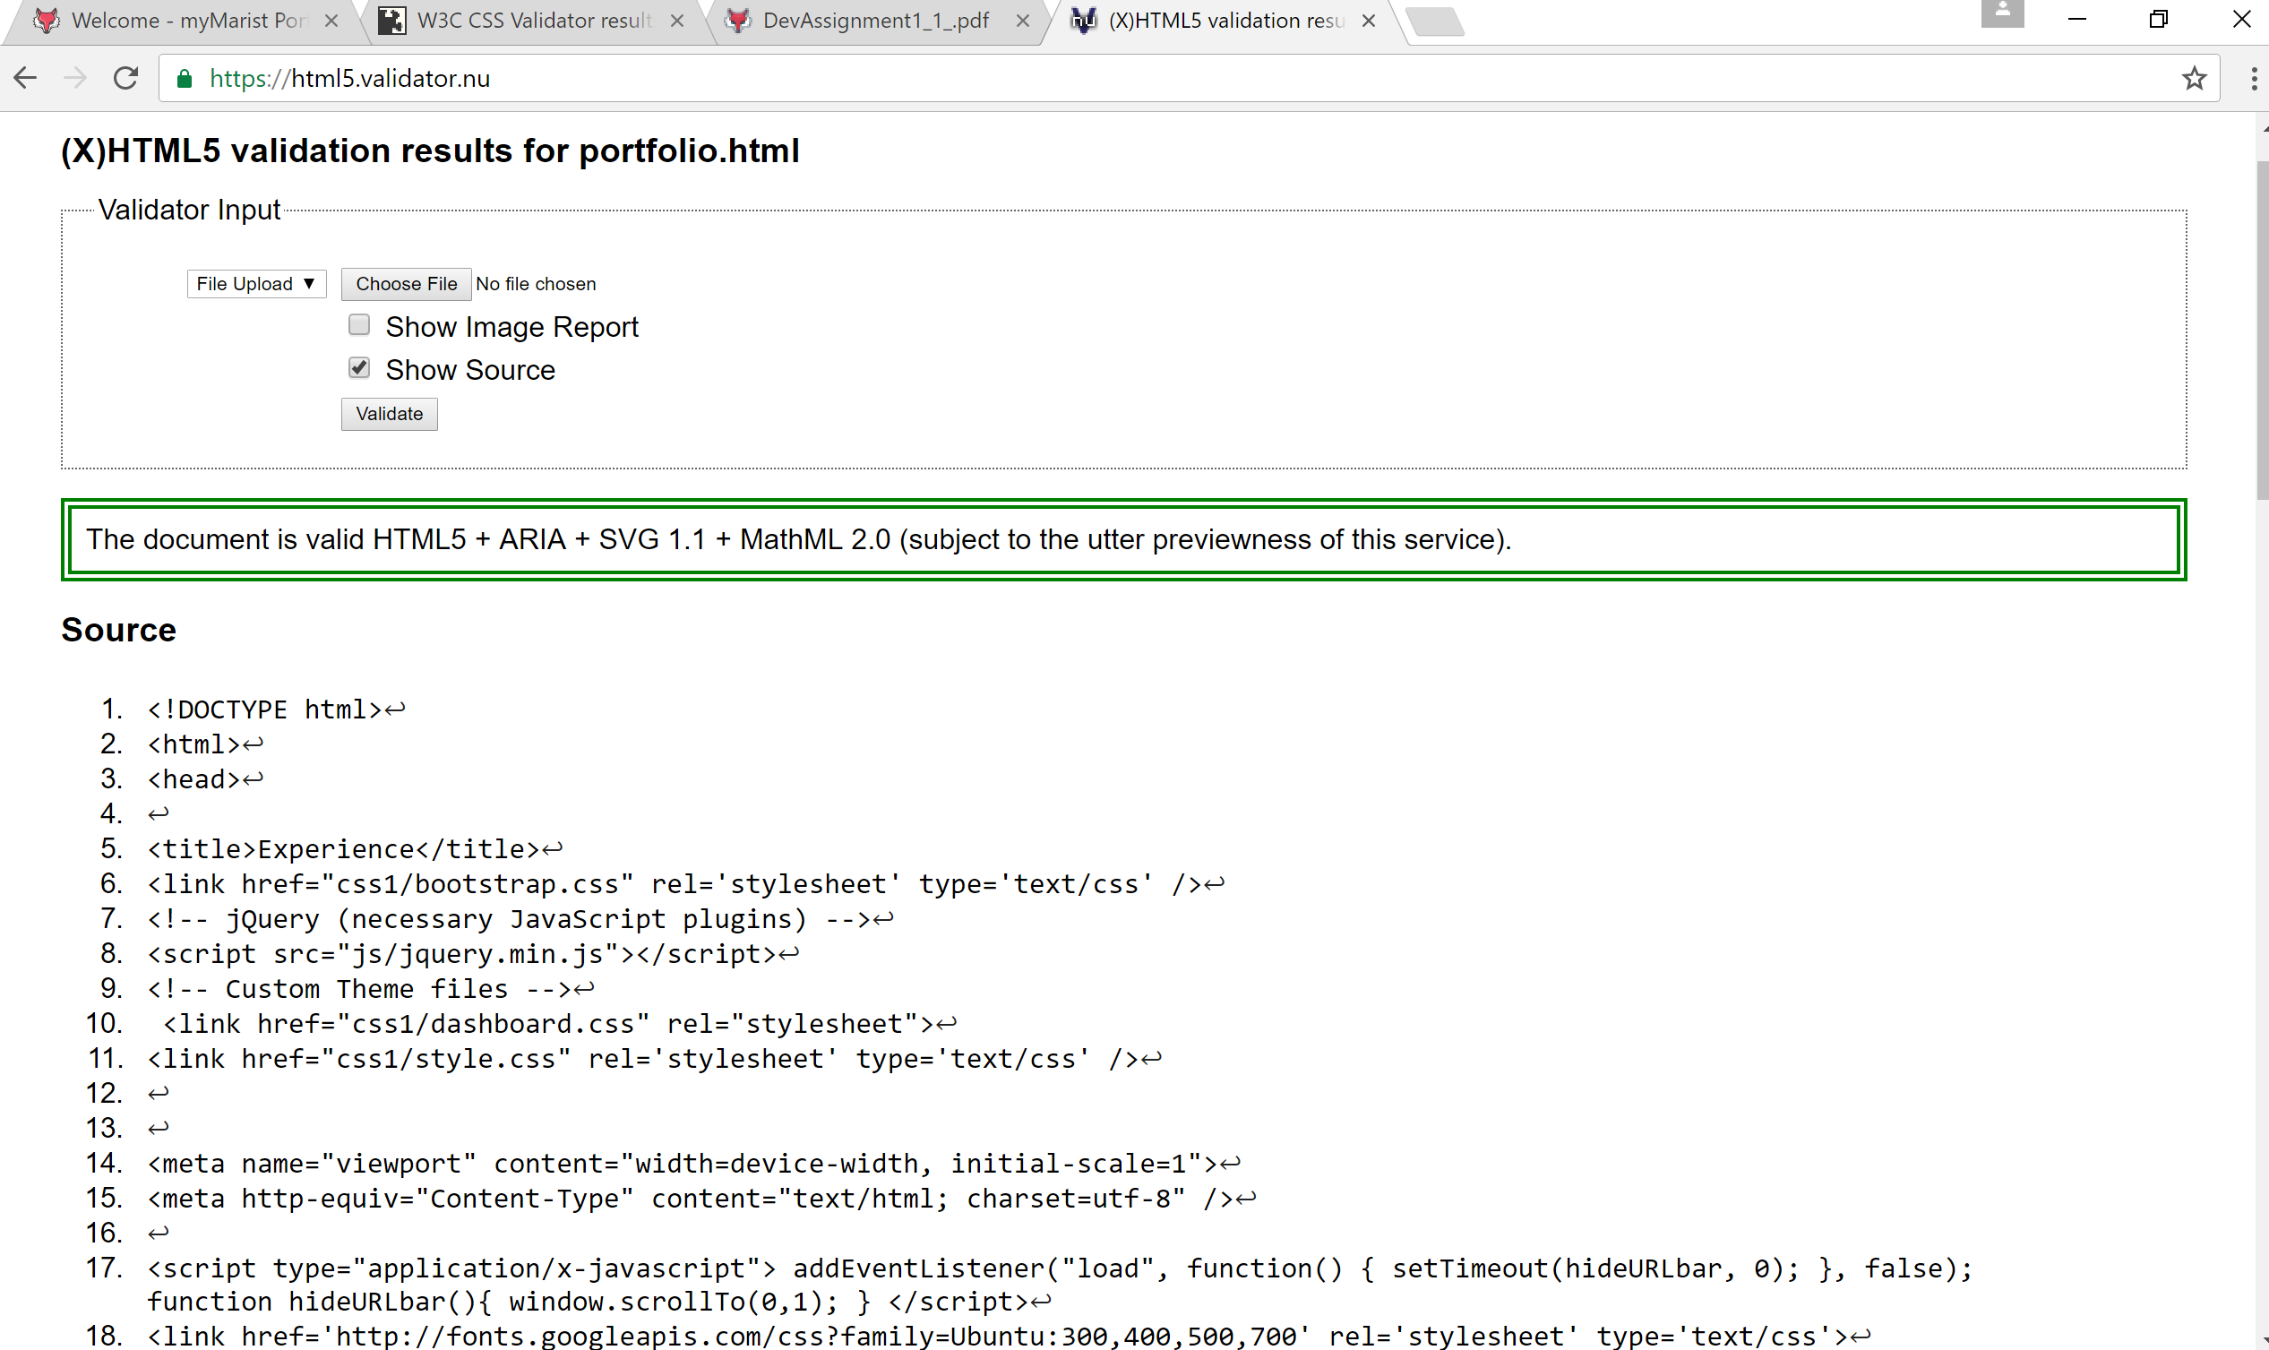

Figure: portfolio.html validation result

🡪 **CSS validation results:**

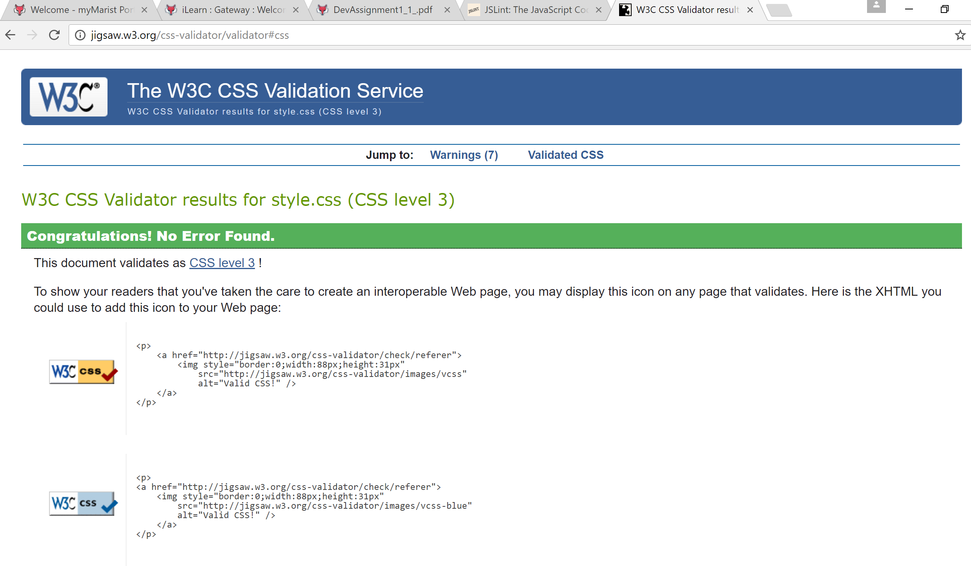

Figure: CSS validation result1

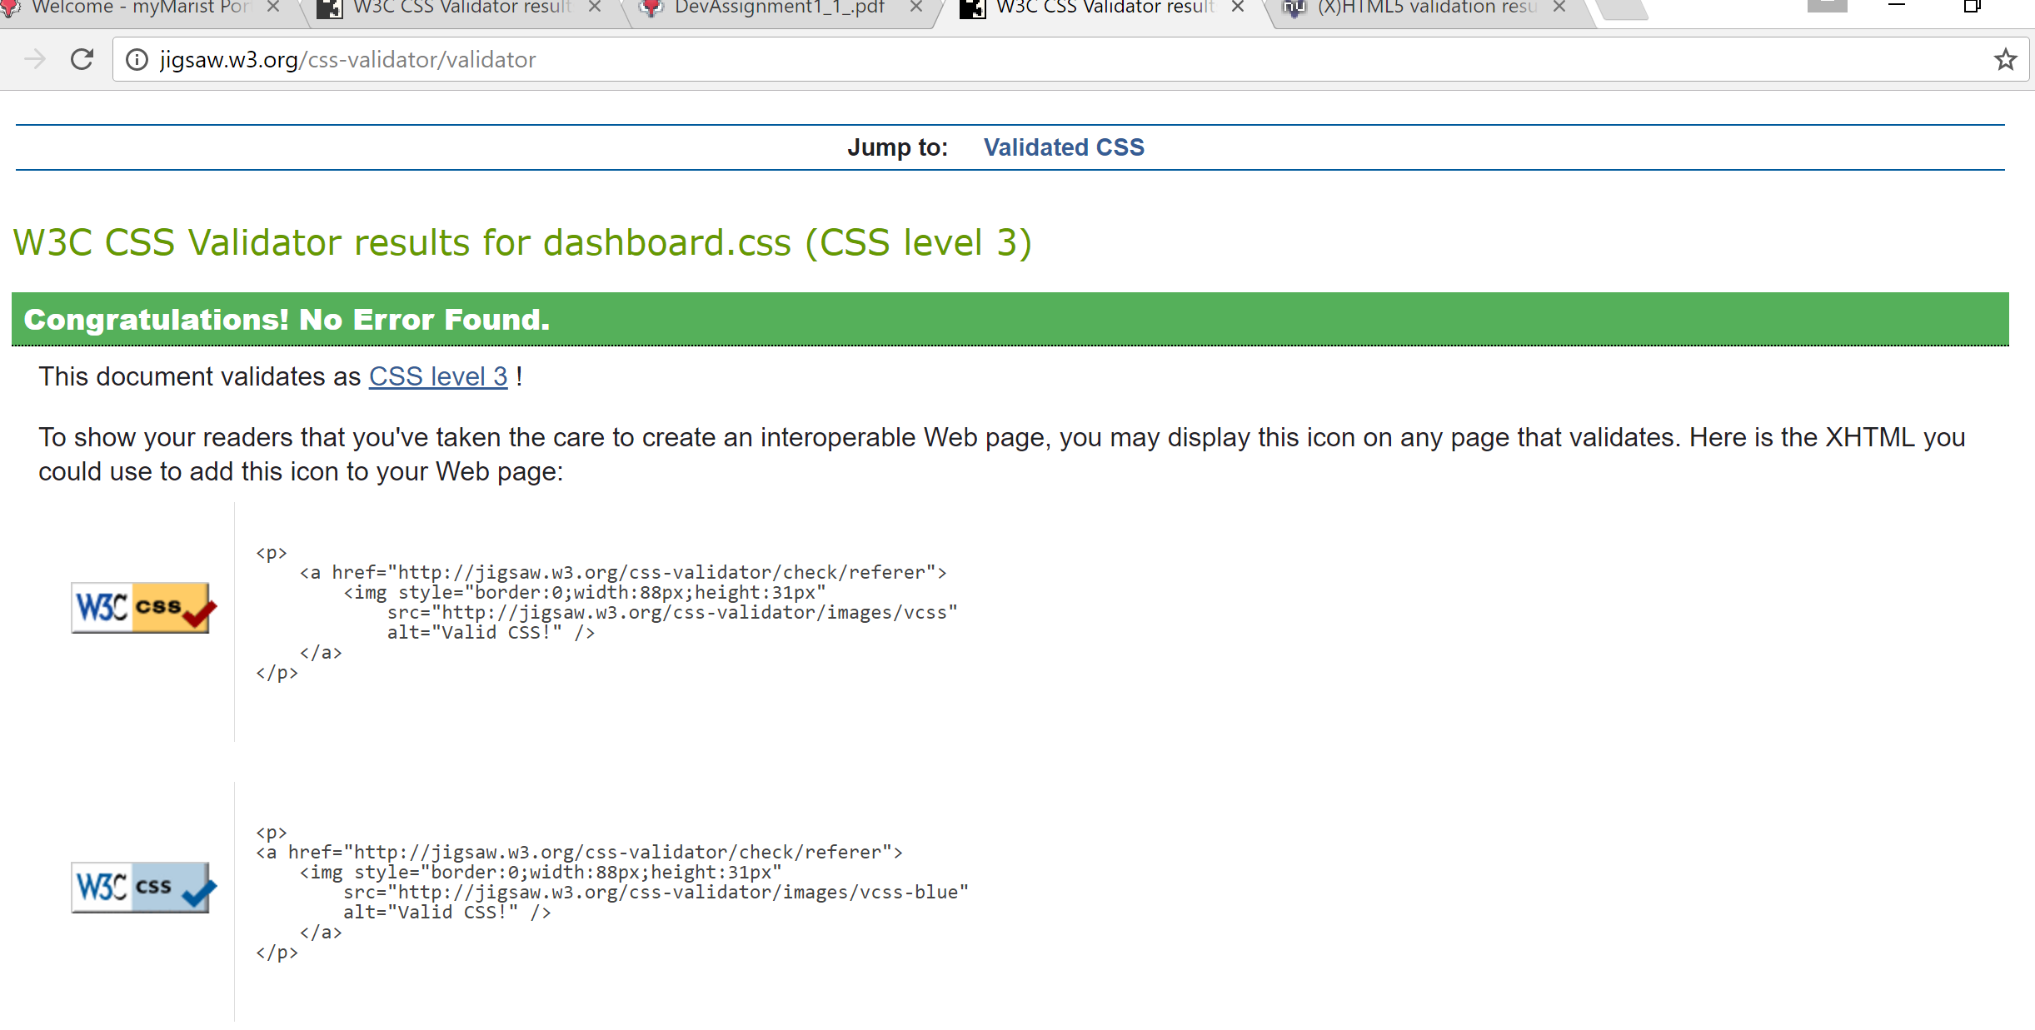

Figure: CSS validation result2

🡪 **Content Outline of my Resume Webpage:**

* **Homepage:** I have included about myself and career objective which includes details of mine. Also, I have included my contact details left side of the page which includes my picture and also download button
* **Skillset:** I have included my Technical skills which includes all my tools which I have been working in my Masters.
* **Work Experience:** I have included all my previous experiences as a student in my first Masters where I did it in Germany.

The outline of my Resume webpage can be viewed in any device where the font size and picture size can be modified according to the length and width of the particular Mobile, Tablet, Computer etc.,